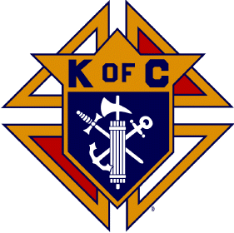
The White Way
Chief Justice Council #2586 Bogota-Teaneck, New Jersey
October - December 2015
The final quarter of the year has arrived. We hope everyone had a great summer. The next few months are the busiest time of the year for family and for our council. We hope we will get strong attendance at our meetings and also at up-coming events. We will need our brother to step up and volunteer to help at all our up-coming events, please make every effort to assist where you can.
A complete list of up-coming events for the next 3 months is outline in this newsletter. We have up-dated our web-site and ask all members to refer to our site for ongoing information.
Our Financial Secretary Brother Steve Weisenbach will be sending out the dues notices for 2016 by the end of November; please do you best to get you dues in early.
Our Council Insurance Agent is Mr. Fred Bivetto, he can be reached at 702-498-7020 or e-mail him at Fred.bivetto@kofc.org, for all insurance questions.

Grand Knight’s Message
Dear Brothers,
I first want to begin by thanking all our members for the honor to serve as Grand Knight for another year. Last year was a very busy year for the council and we plan another aggressive year for 2015-2016.
I must stress how very important it is for our brothers to get actively involved in our council. Many of our current officers have been serving in their positions for several years, because no one has express an interest in taking an officer’s position. We need brothers to come forward for the continued success of our council. Please consider stepping into an officer’s position in the future.
Nick Barese
Grand Knight

Current Events in Progress
We have tickets available for our calendar raffle. We are asking our members to please pick up these tickets and help sell them. The raffle month is December so all ticket must be sold or returned by November 30, 2015. Contact any officer to get your tickets or pick them up at our meetings.
___________________________________________________________________
Upcoming Events
The Following is a list of upcoming events through December of 2015. For any updates to the list please visit our website Teaneckknights.org, or Bogotaknights.org.
October 24, 2015 (Saturday) -------------- ----Mass at the Paramus Veteran’s Home 10:00am
November 8, 2015 (Sunday) -------------------Breakfast fundraiser at Applebee’s in Hackensack N.J. 8AM to 10AM
November 20, 2015 (Friday) ------------------- Alzheimer’s Pasta Dinner 5pm to 8pm at the hall
December 12, 2015 (Saturday) -----------------Breakfast with Santa/Toys for Tots 8am to 10am at the hall
All other events are open to all Brother Knights, your family and friends. Please attend.

Lastly if you are receiving this newsletter by regular mail, please send us your e-mail address as we would like to send all future newsletters electronically. It will help the council save postage cost.

