Congratulations

Chief Justice White Knights of Columbus Council No. 2586 of Teaneck/Bogota has earned the distinction of **Double Star Council** for the fraternal year 2011-2012. This is believed to be the first time that our council has ever been awarded this prestigious honor.

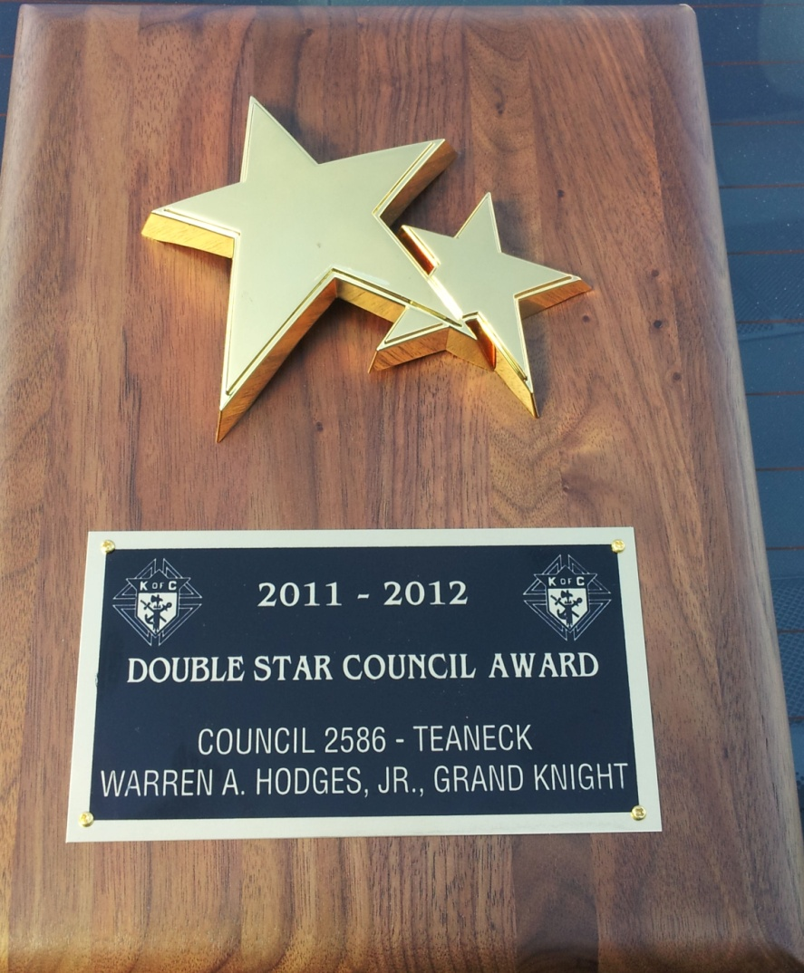The award recognizes overall excellence in membership recruitment and retention, promotion of the fraternal insurance benefit, and sponsorship of service oriented programs. The award was presented by District Deputy Vito Mazza at the Council’s annual Christmas Party on Friday December 21st.

In announcing Chief Justice White Council as a winner, Carl Anderson, chief executive officer and Supreme Knight, said, “Please accept my sincere congratulations upon attaining this prestigious award. Your dedication to the order is seen in the high standard of excellence you have achieved. At the same time, I encourage you to carry forward this enthusiasm to meet the challenges that will face the Knights of Columbus in the years ahead.”

Grand Knight Warren Hodges accepted the award on behalf of the over 245 members of our council. Our council has made great strides in working together for improvement. This award is a tribute to all of the hard work that was performed during the past year. He looks forward to continued success of our council.

In New Jersey there are 361 Knights of Columbus councils. Of this number, 329 of these councils are considered active. For the fraternal year of 2011 – 2012, 30 councils achieved the Star Council award. Only 12 councils were able to achieve the Double Star Council award. Chief Justice White Council was in the top 4% of New Jersey councils. This is very special and we should all share in the pride of this achievement.

Grand Knight’s Message

First, I would like to wish everyone a happy, peaceful and healthy New Year. 2013 is upon us and with it a new opportunity to start fresh. I am very proud of our council and it is very gratifying to see where our council has gone over the past year and a half.

A common phrase that is used around Bergen County and the State is that Chief Justice White Council has come back alive. Members are constantly coming up to me with new ideas and it is very evident that there is new energy in the air. We are averaging 20 members at a meeting and hopefully we can bring that average up even higher. Our Lecturer, Brother Andy Haase has changed our menus at the meeting. Just last night we enjoyed cheeseburger sliders with several different fresh toppings. The Columbian Club recently purchased a barbecue, which is also used after the meetings to create new menu ideas during the warmer weather. Not to say that members are coming to the meetings just for food but we recognize that if you rush home from work and take time out to partake in a meeting that it is nice to have something besides pizza.

I truly wish that every Brother would resolve to take part in our council by coming to at least one meeting this year. Only when we stand together and pray together will the Holy Spirit act through us and bless us so that we are able to make a difference. Here is a short prayer that expresses this more clearly; "Come Holy Spirit, fill the hearts of your faithful and kindle in them the fire of your love. Send forth Your Spirit and they shall be created. And you shall renew the face of the earth."

If we continue to work as a team, each member will endure less and the team will accomplish more. I understand that many of you cannot get out to as many meetings as you would like but that does not need to stop you from getting involved. Please contact me if you have an expertise or an interest that you would like to share. Let’s try to put it to use.

Here is a perfect example; as everyone knows I am probably the worst Grand Knight as far as getting a newsletter out. I know that it should be done on a regular basis but I just cannot get myself to sit down and take care of it. Last night at the meeting, I stated that I would not drink alcohol until this newsletter was on its way out in the mail. My goal is to make sure it is finished, so when I go out Saturday night I will not break my promise. I woke up this morning and started the newsletter and then I was contacted by my neighbor, Ron who wanted to go down to the council and mop the floors. I run down to building to let him in and while I was there, I refilled the beer cooler, cleaned out the other cooler, emptied the garbage, checked the soda system, contacted Bridy Sales to get our CO2 tanks refilled and straightened up around the bar. I then ran over to St. Anastasia to give them flyers for distribution for our Applebee’s Fundraiser on Saturday morning February 2nd. While I am there, I get a phone call from our maintenance supply company notifying me that they will be arriving at the council shortly. I then receive a call that Bridy would like to refill our tanks in 45 minutes. My list of “to-do” errands for the council is still long but I have to run back to the council. If we could all share the load, these tasks would easily be accomplished. I know everyone is busy but if you can fit a little time in your week or month please let me know. Together we can make easy work of these “to-do” items with just a little effort.

We are trying to set up a system of notification through email and our website. This is the most efficient and quickest way of notification. Most of our members have email addresses. If you have not been getting notices on a regular basis please let us know because we either do not have your email address or it is recorded incorrectly. I know a couple of times multiple emails were sent out for the same issue. This is not the accepted policy and only occurred because we are attempting to stream line the system. If you do not have access to a computer, please contact us so we can make arrangement to contact you concerning important issues through mail or telephone. If you do not have computer access, email, telephone or mail, please stop by Pete the Barber on a regular basis and he will keep you up to date on things happening at the council and around town.

Please make an effort to stop down at the council and see the continuing improvements that have been made by many of our members who volunteered time to improve the appearance of our council. I am sure that you will notice a vast improvement.

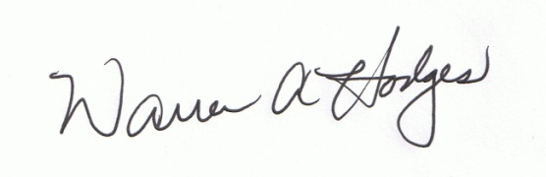Please visit our website to keep up to date on events and notices from our council. Our website is: [www.teaneckknights.org](http://www.teaneckknights.org) or [www.bogotaknights.org](http://www.bogotaknights.org). If you have any suggestions or comments, please go to the “Contact Us” tab, fill out the small form and let us know what you think. This is a continuing work in progress and it will benefit all of our members.

Warren A. Hodges  
Grand Knight

Membership

Membership is key to the success of any organization. We currently have about 246 members. Many of these members are up in age and have worked very hard in the past for our organization. They are now involved with attending to spouses, helping with grandchildren and even attending to their own health issues. It is now time to develop new and younger members who will carry our council into the future. Our older members are still the foundation but the newer members will help to give us a new structure. This is where we need your help. This week while you are going about your normal activities, ask yourself is the young man that you are talking to a member of the Knights of Columbus. It is a good possibility that he is not. This is now your opportunity to ask him to join. We are desperately seeking new members. Members are not required to give us any set amount of hours and they are not forced into any activities. Most members come, observe and then make the choice to get involved. There are many sons, son in laws, grandsons, nephews, neighbors, work associates or friends that are Catholic men that have never been asked to join the Knights of Columbus.

If you know of a Catholic gentleman who has the values of Charity, Unity, Fraternity and Patriotism in their heart, then speak to them about becoming a Knight. Our council is what WE make it. If you cannot attend meetings or get involved as much as you would like, then maybe you could speak to someone who would like to join and become active “at their own pace”.

Our Council Website

[www.bogotaknights.org](http://www.bogotaknights.org) or [www.teaneckknights.org](http://www.teaneckknights.org)

Our council has an award winning website. Last year the Chief Justice White Council was awarded 1st Place in the State of New Jersey for its website. It was a great honor to receive this award and our Webmaster Richard Castelluccio has done a great job with its construction. Our website is only as good as the information entered into it. If you do not give us information then we are not able to announce it. Please contact us when there is information you would like to share with your Brothers. Whether it is a cry for help or birth notification, communication takes at least two people to be successful, a sender and a receiver. By creating our website we will be able to deliver information quickly to those who may need to know. This is a partial list of information you can look forward to finding on our website:

* Death Notifications
* Sick or Distressed Notices
* Council Functions
* Fundraisers
* Charitable Events
* Royal Knights Room information
* Newsletters
* Hall Rental Information
* Photo Gallery
* Membership/Degree Information
* Important Contact Information
* Information concerning other Brothers

To be successful, we need you to help us. When returning your dues statement, please include your email address. Be assured that we respect our Brother’s privacy, this list will never be shared with others and you will only receive information from our council. The emails you receive will most likely refer you to the website for the new newsletter or other council information. We are confident that by using this system everyone will be able to receive information quickly and accurately, especially when we have to notify our membership concerning a death.

For those of you that are into social networking, through our website you will be able to “Like Us on Facebook” or “Follow Us on Twitter”.

**Meetings**

Our meetings are on the 2nd and 4th Thursdays of the month. Please check your calendars and try to attend a meeting. Every effort is made to assure these meetings take no more than 60 minutes.

February 14th – No Meeting Valentine’s Day

February 28th – Meeting

March 14th – Meeting

March 28th – Meeting

April 11th – Meeting

April 25th – Meeting

May 9th – Meeting (Nominations of Officers)

May 23rd – Meeting

June 13th – Meeting (Election of Officers)

June 27th - Meeting

**Upcoming Events**

**Saturday, February 2nd - Applebee’s Breakfast Fundraiser**

We are holding a fundraiser at Applebee’s, 450 Hackensack Ave, Hackensack adjacent to the Home Depot and Staples. The breakfast is from 8:00 AM to 10:00 AM and includes Eggs, Pancakes, Sausage, Bacon, and choice of beverage. Tickets are $10.00 and everyone is welcome. Come down and bring your family.

**Saturday, February 9th – Mass at Veterans Home**

We will be meeting in the Knights parking lot or meeting directly at the Veterans Home in Paramus. We will set up the cafeteria for mass and escort any of the Veterans that would like to attend Catholic Mass. After Mass we will escort the Veterans back to their assigned areas. We are usually depart from the Veterans Home by 11:30 AM. This is a worthwhile act of Christian Charity and one of the most heartwarming events you can be involved in doing. Everyone is welcome to join us.

**Monday, February 18th – Memorial Mass**

There will be a Memorial Mass for all of our departed Brothers at the Council at 10:00 AM. Mass will be offered in the hall and there will be a small reception afterwards. All are invited.

**Saturday, April 27th – Spaghetti Dinner for Special Olympics**

This will be our 2nd year sponsoring the Lincoln Tunnel Challenge Spaghetti Dinner for Special Olympics. The dinner is held at the Sheraton Lincoln Harbor Hotel from 6:00 PM to 9:00 PM for individuals checking in for the Lincoln Tunnel Challenge the next morning. Our members act as servers and the food is prepared by Vitale’s Restaurant. Last year we helped raise over $1000.00.

**Saturday, May 4th – Hawaiian Murder Mystery**

Our Council will be holding a Hawaiian Murder Mystery in our hall. This is guaranteed to be a great event. The hall will be decorated in Hawaiian theme and we will be serving an authentic Hawaiian buffet. The food will include roasted pig, chicken, teriyaki steak and more. There will be Hawaiian music and even a Hula Dancer. So grab your Hawaiian shirt and a bunch of friends and come join the fun. Tickets will be $45 in advance or $50 at the door. Please call the council to get tickets or for more information, 201-836-9719.

**We would like to formally welcome the following**

**New Members**

* Eddy M. Almonte
* Darrell S. Arevalo
* Alex Breuss
* Evaristo Burdiez Jr.
* Michael Cullen
* Nelson Estevez
* Tito Jackson
* Michael J. Krynicky
* Matthew Luciano
* Andre A. Montagne
* James O’Brien
* Patrick O’Brien
* Sean O’Brien
* Timothy Regan
* Jose A. Rodriguez
* Thomas Smith
* Ara Toutounjian

**Columbian Club Corner**

* We are happy to say that there are vast improvements in our building. The entire second floor has finally been cleaned out and is now underway for a new design which will include an office and a kitchen storage area. This project has taken longer than anticipated but great strides have been made. We will also have available a second floor meeting room with access to a small bathroom.
* The Columbian Club received donations of a 6’ video projection screen and a video projector which can be used for meetings and training sessions in the hall.
* Our improvements are a continuing effort with the goal of making our facility the finest it can be. If you are able to help with ideas or manpower, please contact Len Nicolosi or Warren Hodges.
* The Columbian Club would like to thank all of you that have put your time and effort into making the improvements that we now enjoy especially John Albert, Nick Barese, Ron Berthoumieux, Joe Carnevale, Tom Conforti, Andy Haase, Pat McHale, Tim McHale, Ken O’Donnell, Steve Quinn, Walter Zberski and anyone else that I unintentionally forgot.
* Please remember that our newly improved hall is available for rent. You can now proudly recommend it to others. Call 201-836-9719 and leave a message for Nick Barese and he will be able to give you all of the details and availability.

**Royal Knights Room**

As most of you already know we have named our renovated bar as the Royal Knights Room. We are now offering it to members holding Fantasy Sports Drafts. For a small fee, you can have your draft here. There are numerous benefits in using our facilities: no interruptions by others, you may bring in your own food, we have televisions to receive the latest sports news or you may display the progress of your draft, we can offer drink specials on draft beer, or even move your draft to the hall if your group is big enough. Wireless Internet connection is coming soon! Contact Warren Hodges for further details and to make arrangements to have your best Fantasy Sports Draft.

**Opinions Wanted**

We are looking for your opinion to help us make positive decisions for the Royal Knights Room.

* In the past, we have special drink nights in the Royal Knights Room and they have been very successful. Is this something that would interest you and your friends?
* We have had the NCAA Basketball Tournament Package service for the past four years and it has not attracted too many viewers. Is this because you did not know we had the package or is it more attractive for you to watch it somewhere else? Please let me know if you would like the NCAA Basketball Tournament Package this year. Also, what would entice you to come down to the Royal Knights Room to watch the games? Drink specials, food, assurance that the bar will be open, please give us your opinion.
* We know and respect the fact that members have more of a life than just the Knights of Columbus. There are plenty of other places to go. What we are looking for is your opinion on what you think may make it better. Please tell us what days you would like to see the bar open. Would you like to see different beers, alcohol, wine or non-alcoholic drinks? Would the addition of video games or music nights entice you to visit more often? Does the addition of food being offered seem to be more inviting?

We appreciate your opinion on the above issues and we are inviting all members to let us know what they think. Your opinion does not commit you to anything. Please email Warren Hodges at [w.a.hodges@verizon.net](mailto:w.a.hodges@verizon.net) with your comments.

**Help Wanted/Items Needed**

* An individual or company with the expertise in designing and installing lighting and ceiling tiles for our hall.
* Bartenders for the Royal Knights Room. If you can volunteer for once a month, it would greatly be appreciated.
* Office Equipment in good condition for our upstairs office. We are looking for a desk and file cabinets. Also a computer and a copy machine in good condition.
* Refrigerator or Freezer in good condition for our upstairs kitchen storage area.
* Refrigerator/freezer in good condition for our kitchen
* Deep fryer or other kitchen appliances in good condition for our kitchen and cooking services.
* Any connections on purchasing new or slightly used high top bar tables and chairs for the Royal Knights Room

**INSURANCE NEWS**

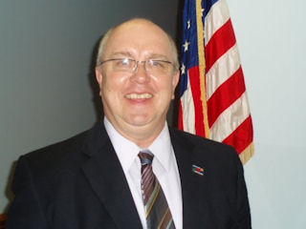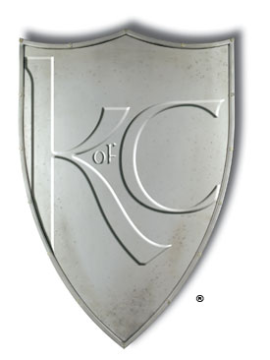Teaneck Justice White Council #2586 proudly announces that Brother Dan Kurek has been re-assigned to the Council as its representative field agent. As a thirty-one year member of the Order, his wealth of experience and knowledge allows him to offer valuable and proven advice in planning sound financial futures for Knights of Columbus families. Born and raised in a family owned business in Wisconsin, Dan knows first-hand the difficult decisions that working families face when attempting to navigate today's turbulent financial times. Since the onset of his career, he has always committed to excellence in customer service. His accomplishments are many. He's attained the designations of Fraternal Insurance Counselor (FIC) and Fraternal Insurance Counselor Fellow (FICF). He is a perpetual leader in his Council, his community and the Knights of Columbus agency force. Through the first quarter of 2008, he ranked sixth within the Knights of Columbus Agency Department in new applications on members. Dan was awarded the "Outstanding Service Award" in 2008 from the Bayonne New Jersey Star of the Sea Council #371. The award marked the first time ever that the Council had bestowed such an honor upon its field agent. Dan was recognized as "Agent of the Year" by his Agency for 2010 and received the same award in 2009. He has been ranked in the top ten percent of all Knights of Columbus field agents in total business written. His efforts in the Norwood Immaculate Conception Council #9021, as well as the Rochelle Park Sacred Heart Council #2842, and the Ramsey Reverend Patrick Pindar Council #3962 helped them to achieve Star Council recognition for 2012. However, his greatest accomplishments are his wife of twenty-four years, Kimberly, and their two beautiful children, Billie Jean and Nick. Billie Jean is a sophomore at Rutgers University and Nick is a junior at Teaneck High School. Dan is a 1983 graduate of the University of Wisconsin.

Regardless of your financial position, attaining your goals remains Dan's most important objective. His high level of energy and commitment to his members has allowed him to help hundreds of Knights of Columbus families secure their financial futures. His strength with the members is quite clear. He offers simple solutions and exceptional opportunities to move our families ahead financially. Give him a call today. He's here to help you................and your family, for life, knowing always that our core Catholic values guide us in everything we do. You can reach Dan at (201)-615-4975 or by email at [daniel.kurek@kofc.org](mailto:daniel.kurek@kofc.org). You can also visit him on the web at [www.kofcnewjersey.org](http://www.kofcnewjersey.org).